EMBEDDED C PROGRAMM#include <stdint.h>

1.
#include <stdio.h>

int main() {
// 32-bit register initialized to 0
uint32_t reg = 0x00000000;

// Set the 5th bit (position 5)
reg |= (1 << 5);

printf("Register value in hex: 0x%08X\n", reg); // Output: 0x00000020
return 0;
}
</stdio.h></stdint.h>ING 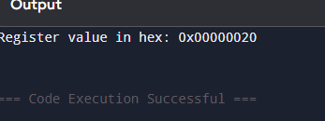
3 #include <stdio.h>

int main() {
unsigned char register_val = 0b00000000; // Initial value (0)

// Toggle the 7th bit (indexing from 0 to 7)
register_val ^= (1 << 7);

printf("After toggle: 0x%02X\n", register_val); // Output: 0x80
return 0;
}
</stdio.h>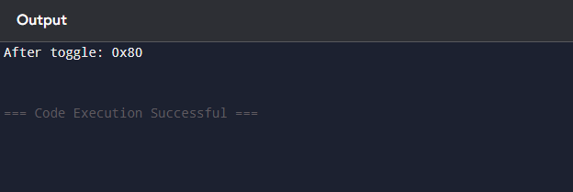
5 .
#include <stdio.h>

/**
* Checks if the bit at a specific position is set.
* position: The 0-based index of the bit (e.g., 4 for the 5th bit).
*/
int is_bit_set(unsigned int num, int position) {
// Create a mask by shifting 1 to the left by 'position' times
unsigned int mask = (1 << position);

// Use bitwise AND to see if that specific bit is 1
if (num & mask) {
return 1; // Bit is set
} else {
return 0; // Bit is unset
}
}

int main() {
unsigned int number;
int bit_pos = 4; // Checking the 4th bit position

printf("Enter an unsigned integer: ");
if (scanf("%u", &number) != 1) return 1;

if (is_bit_set(number, bit_pos)) {
printf("The bit at position %d is SET (1).\n", bit_pos);
} else {
printf("The bit at position %d is UNSET (0).\n", bit_pos);
}

return 0;
}
</stdio.h>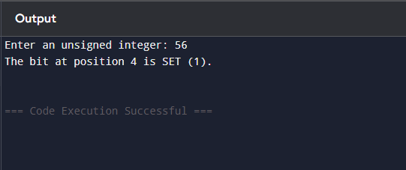
6 .
#include <stdio.h>

int main() {
int num, shift;

printf("Enter an integer: ");
scanf("%d", &num);
printf("Enter number of positions to shift: ");
scanf("%d", &shift);

int leftResult = num << shift;

int rightResult = num >> shift;

printf("\nOriginal number: %d\n", num);
printf("After Left Shift (<< %d): %d\n", shift, leftResult);
printf("After Right Shift (>> %d): %d\n", shift, rightResult);

return 0;
}

</stdio.h>
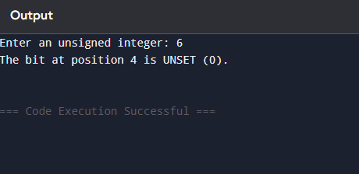
7
#include <stdio.h>

int main() {
int a, b;
printf("Enter two integers: ");
scanf("%d %d", &a, &b);

printf("\nBefore swapping: a = %d, b = %d\n", a, b);
a = a ^ b;
b = a ^ b;
a = a ^ b;

printf("After swapping: a = %d, b = %d\n", a, b);

return 0;
}

</stdio.h>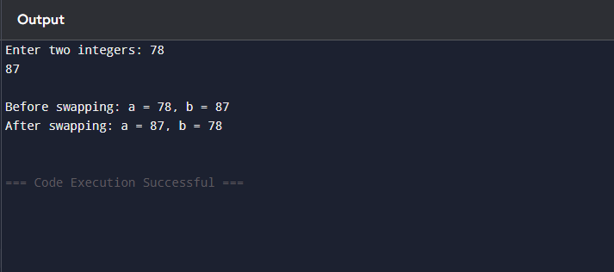
8
#include <stdio.h>

unsigned int clearAllExcept(unsigned int n, int pos) {

unsigned int mask = (1 << pos);

return (n & mask);
}

int main() {
unsigned int num = 15;
int position = 2;

unsigned int result = clearAllExcept(num, position);

printf("Original: %u (Binary: 1111)\n", num);
printf("Position to keep: %d\n", position);
printf("Result: %u (Binary: 0100)\n", result);

return 0;
}
</stdio.h>